**Class Attendance Mobile App**

Use Case Specification

Submitted to:

Asst. Prof. Ma. Rowena C. Solamo

Faculty Member

Department of Computer Science

College of Engineering

University of the Philippines, Diliman

Submitted by:

Atienza,​ ​John​ Oliver

Austria,​ ​Ronnel​​ Roi

Gabriel,​ ​Kristianne​ Arielle

In partial fulfillment of academic requirements

for the course

CS 191 Software Engineering I

of the

1st Semester, AY 2017-2018

***Unique Reference:***

The documents are stored in the GitHub repository:

<https://github.com/rbaustria/ClassAttendanceMobileApp>

***Document Purpose:***

The document provides the Use Case specification of the software, Class Attendance Mobile App.

***Target Audience:***

The target audience of the document are: the developers of the software, future developers who wish to extend it, and the professor.

***Revision Control***

*History Revision:*

|  |  |  |  |
| --- | --- | --- | --- |
| ***Revision Date*** | ***Person Responsible*** | ***Version***  ***Number*** | ***Modification*** |
| 10/10/17 | John Oliver | 1.0 | Initial Document |
|  |  |  |  |

*Use-Case Name*: 2.6 Edit student information

*Description:* This use-case edits the information of an existing student from the list of students.

*Preconditions:* Have at least one existing student

*Flow of Events:*

|  |  |
| --- | --- |
| ***Scenario Name*** | ***Description*** |
| Scenario 1 (Basic Flow)  Teacher successfully edits student information. | 1. Teacher views the list of classes then selects the student that he/she wants to edit the information of. 2. The teacher edits the information of the said student and tries to save it 3. The application checks for any error on the entered data. If everything is valid, the student information is updated. |
| Scenario 2  Teacher fails to edit the student information | 1. Teacher views the list of classes then selects the student that he/she wants to edit the information of. 2. The teacher edits the information of the said student and tries to save it 3. The application checks for any error on the entered data. If everything any error is detected, it is displayed by the application and the student information is not updated. |

*Activity Diagram of the Flow of Events:*

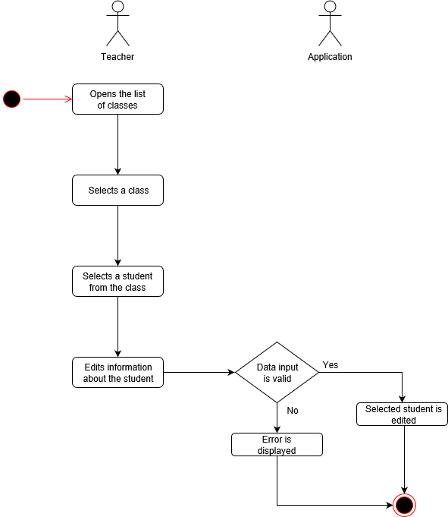

*Postcondition:* The selected class is edited or not.

*Relationships:* NONE

*Special Requirements:*

NONE